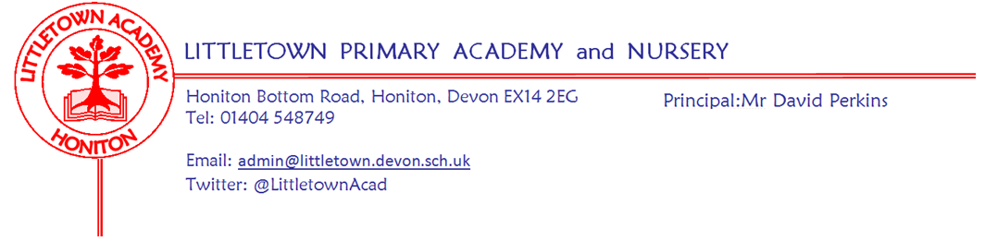
Year 1 Summer Term 2023 Information
Welcome
Welcome back. We hope that you all had a restful break over the Easter holiday and hope your child is excited to be back for the Summer Term.

Literacy
Year 1 children will continue to have a Literacy lesson including phonics teaching in a group of children of similar ability. The adult in each group will revise known sounds as well as teaching new sounds. The children will be reading and writing, practising what they have been consolidating or newly taught. Children will be bringing home the reading books that match their daily teaching. The children will bring home 2 books every 3 or 5 days depending on their Reading level. One book will be a Black and White version of the Story that the children have been learning to read in class. The second book will have the same sounds and words but within a different story. Your child will be able to read these books. They will become confident and successful readers. We are focusing on capital letters, finger spaces, full stops, adjectives and proof reading our own writing in the Summer term.
Thank you for all your support with listening to your children read during the Spring Term. We kindly ask all parents to read with their child each night and record what they have read. There is a space for you to comment on how they have read. These reading records are to be handed in on a Monday so that the teachers can check on how your child is progressing with their reading at home.
Phonics
Children in Year 1 throughout the country will all be taking part in a phonics screening check during the same week in June 2022. The Phonics Screening Check is a list of 40 words that children read one-to-one with a teacher. The list is a combination of both real and made up, non-words (alien words) which rely purely on using phonics to decode. The non-words are words that have been made up and will be shown with a picture of an imaginary creature to help them. The phonics screening check will take place on a one to one but the children will largely be unaware of it being a test and have already participated in some practice ones. Phonics works best when children are given plenty of encouragement and learn to enjoy reading and books. In order to help, read as much as possible to and with your child. When children become more capable readers they develop the skill of word recognition. However, it is important that children continue to practise good sounding out and blending so they don’t fall into the trap of guessing the wrong word. Parents play a very important part in helping with this. Some simple steps to help your child learn to read through phonics:
- With all books, encourage your child to ‘sound out’ or ‘Fred talk’ unfamiliar words and then blend the sounds together from left to right rather than looking at the pictures to guess. Once your child has read an unfamiliar word you can talk about what it means and help him or her to follow the story.
- Try to make time to read with your child every day. Grandparents and older brothers or sisters can help, too. Encourage your child to blend the sounds all the way through a word.
- Play lots of sound and listening games with your child. Word games like ‘I-spy’ can also be an enjoyable way of teaching children about sounds and letters. You can also encourage your child to read words from your shopping list or road signs to practise phonics.
- An excellent website for phonic games is: http://www.phonicsplay.co.uk All phonics phases are covered on this website.
- Additionally, our school website has lots of helpful information and videos to watch https://www.littletown.devon.sch.uk/website/psc_-_phonic_screening_check/647190
At parent’s evening we sent home a sheet with the sounds your child was finding difficult to recognise. It is important to practise these sounds in school and at home.

Maths
The children will have a Power Maths lesson for an hour every morning. We will continue to practise and develop the children’s number skills so that they are confident with numbers to 50, and beyond.

In the first half term the children will be practising multiplication and division skills. Within multiplication we will be looking at multiples of 2, 5 and 10 and doubling. We will then move onto division by learning to share and group equally. The children will learn about halving and quartering shapes, before moving onto given amounts.

In the second part of the Summer term we will be looking at counting, partitioning, comparing and ordering numbers to 100. We will then look at number bonds to 100 and and learn how they can help us with addition and subtraction. We will then move onto learning about time, looking at calendars, months of the year and reading the time to o’clock and half past. The last topic in maths for the Summer term will be looking at money; recognising, ordering and counting coins and notes.

PSHE (including Relationship, Sex and Health Education)

In Jigsaw, the first half term’s topic is ‘Relationships’. Children will be able to explain why they have special relationships with some people and how these relationships help them to feel safe and good about themselves. They will also be able to explain how their qualities help these relationships and give examples of behaviour in other people that they appreciate and behaviours that they don’t like.

After half term our topic in PSHE will be ‘Changing Me’. This topic refers to Relationships and Sex Education. Specific details will be sent out separately in the Summer Term.

Outdoor Classroom
Children will have outdoor classroom days throughout the year. An email will be sent once these term dates are decided. Please ensure children are dressed appropriately in old, warm clothes and have a waterproof coat. Welly boots should be brought to school in a named carrier bag that they can be returned to when they are muddy.
Our first Outdoor Classroom day of this term is Wednesday 24th May.

Foundation Subjects
We follow a topic led curriculum that is broad and balanced and aims to develop the children’s skills, knowledge and creativity. At the start of each topic there will be an exciting ‘engage’ event to hook the children.
This term our topic is ‘School Days’
Please find more information about our topic and opportunities for home learning in a separate attachment.

PE
Children will receive 2 hours of PE each week during the Summer Term. Children will come to school in their PE kits on their allocated days.
Our PE units are:
Monday Afternoons (Both Classes): Summer Term 1:Team Building/ Summer Term 2: Invasion
Friday Mornings (Both classes): Summer Term 1: Athletics/ Summer Term 2: Athletics

Key reminders
Collecting at the end of the day: At the end of the day (3.30pm), children will be accompanied out to the front playground where we will send them off once a parent/guardian can be seen. We will not let children go until we can see whoever is picking them up, so please come forward to collect your child.
Clothing: Please ensure all items are named including PE kit and shoes.
Packed Lunches: We have peanut allergies in school so we ask that no children have nuts or nut based snacks/spreads in their lunchboxes. We are a healthy school and ask that children do not bring in chocolates or sweets for lunch.
School Dinners: Please ensure you book your child’s school dinner by Friday midnight for the following week. If your child does not eat enough school lunch we will send a note home to inform you.
Mid-morning Fruit & Milk/Snack: Fruit is provided at break time. Named water bottles must be brought in from home and children are encouraged to drink regularly (these are kept in the classroom). In line with our school policy, only plain water is allowed in the water bottles which are bought into the classroom. If you would like your child to have milk each day you can register online at www.coolmilk.com or print the form and post for free.
Birthdays: If it is your child’s birthday they can come to school in their home clothes. Please do not bring cake/sweets in for other children.
Toys: We ask that toys/valuables are not brought into school due to them getting lost or damaged.
Junk Materials: We are desperate for yogurt pots, small boxes and cardboard tubes (not toilet rolls). Please ensure they are clean because the children use these to build models with. If you have any please bring them in a bag.

Key dates for the Summer term
Monday 17th April Term begins for children
Monday 1st May May Bank Holiday
Thursday 18th May Victorian Day
29th May – 2nd June Half Term (1 Week)
Monday 19th June Y1 School Trip to Ax Valley
Tuesday 25th July Term ends for children
Tuesday 11th July Sports Day - Key Stage 1 - Afternoon

Outdoor Classroom:
Wednesday 24th May (both classes)
Summer 2 Outdoor classroom date to be confirmed (both classes)
Thank you for your support
The Year 1 Team
Miss Chalmers: class1sc@littletown.devon.sch.uk Miss Meecham: class1lm@littletown.devon.sch.uk

