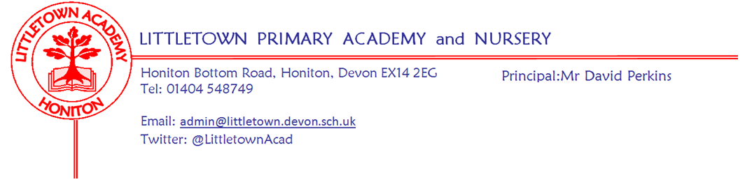
Year One – Remote Learning Update 17 April 2020
Dear Children, Parents & Carers,

We hope you are all keeping well, staying safe and have enjoyed the lovely Easter weather. From Monday 20th April we are going to use a Padlet Learning Wall to share activities and ideas for your home learning. All of the teachers at Littletown will be using this approach to ensure consistency across school. The Year One Padlet link is as follows:
https://padlet.com/lucymeecham/rdp6aonqtr9n06mz
On the page you will find video messages from Mr Perkins and the class teachers alongside ideas to keep you busy. Each note has an idea/activity, and sometimes a link to a website if needed. As time goes on we will add new notes with up-to-date learning so please look at the wall weekly.
We love seeing what you have been up to by e-mail, thank you for everything that you have sent us so far! You can upload photos, videos and messages. We have enjoyed seeing you all be so busy making rainbows, cooking, writing and being creative.
A reminder of the class emails:
Miss Meechams Class: class1lm@littletown.devon.sch.uk
Mrs Veevers Class: class1cv@littletown.devon.sch.uk
Remember Mr Perkins will still be sharing and celebrating #littlebuilders, #littlegreenfingers, #littlechefs and #littetownwindows. Email the school photos or share directly via our facebook page and twitter feed (@LittletownAcad).
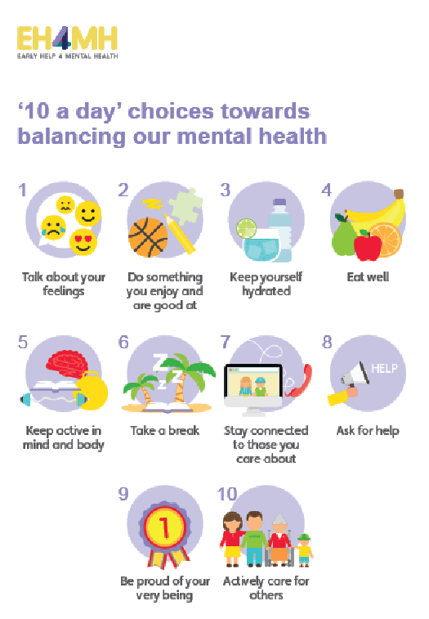
Lots of learning in year one is still done through play, Play is a crucial part of your child’s development, therefore opportunities to learn through constructing with junk materials or construction sets like Lego provide experiences for physical development but also encourage problem solving, planning, discussion, adapting and reviewing skills. Playing with small world or role playing/imaginative play can encourage language development as well as offering up opportunities to mark make, use mathematical skills and develop their social skills and understanding of the world.

NumBots
We’re using this super online resource to support our children’s maths education. The creators of Times Tables Rock Stars have produced a platform for boosting addition and subtraction skills, called NumBots.
NumBots is an online game and playing little and often will significantly improve your child’s recall and understanding of number bonds and addition and subtraction facts. These are critical foundations in maths so we are excited by the impact NumBots will have. All children start at the same place in Story mode, and when they get to a certain stage they will unlock Challenge mode.
The NumBots app is available to download on all apple and android devices.
Everyone should have been sent their login details so that they are able to access NumBots. If you have not received this please e-mail us and let us know.

This is a really strange time for everyone, especially for the children who need time. Time – it allows them to process what is going on and make sense of their feelings. If the only thing you manage in the day is some of the ’10 a day’ then you and your family are having a good day. This is a time to spend as family, to talk, share, play, tell stories and snuggle.

Take care, stay safe and look after one another,
The Year One Team
Please note message from Mrs Trim and Mrs Childs:
This is the link that all parents can use to access the SEND/SAFS padlet page. There is a lot of useful information, activities, links... for our SEND children and families.
https://padlet.com/lianechilds/ewjn9i9gxfpw

