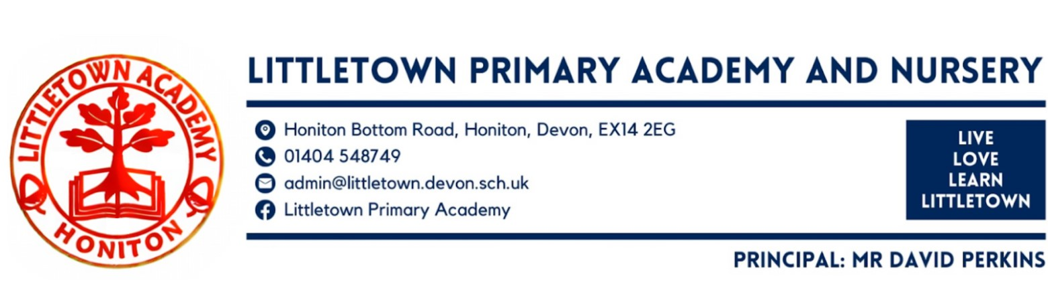
Year 1 Autumn Term 2025 Information

Welcome
Welcome back. We hope that you all had a restful break over the Summer holidays and hope your child is excited to be starting Year 1.
Literacy
Year 1 children are taught Literacy, including phonics teaching, in a group of children of similar ability every morning. This Autumn, the children will be learning to:
- recognise sounds and blend them together (Fred Talk);
- decode letter/sound correspondences quickly and effortlessly;
- read ‘tricky’ (red words) on sight;
- read fluently and with expression;
- understand what they have read;
- spell quickly and confidently when writing, by segmenting the sounds within words;
- acquire a fluent handwriting style.
Each day, children will revise known sounds as well as learning new sounds. The children will be reading and writing, practising what they have been taught. Children will be bringing home the Reading books that match their daily teaching. The children will bring home 2 books every 3 or 5 days, depending on which colour book they are reading. One book will be a Black and White version of the Story that the children have been learning to read in class. The second book will have the same sounds and words but within a different story. Your child will be able to read these books well as the book is matched closely to their phonetic knowledge. This should help them to become confident and successful readers. Along with these books, your child will also bring home a spelling sheet to help them practise writing red words and words they will need to spell in their literacy lesson.
Children also have Funky Finger sessions which provide opportunities to work on the children’s fine motor control including; cutting with scissors, pencil grip and control and letter formation. We will be focusing on children using their phonics to write short sentences and teaching children the importance of finger spaces, capital letters and full stops.
Maths
In Maths, we follow the Power Maths programme. This is a progressive scheme from reception to year 6. The scheme focuses on all the different aspects of maths including number, measures, money and shape. Throughout the first half term we will be focusing on numbers. We will be counting, ordering and comparing numbers to 20, finding one more and one less and looking at part whole models and how they can help us with our number bonds. We will also be looking at addition and subtraction within 10.
Science - Everyday Materials & Human Senses
In Science, children learn that objects are made from materials. We will identify a range of everyday materials and their sources. Children will investigate the properties of materials and begin to recognise that a material's properties define its use. We will also explore human senses. Children learn that humans are a type of animal known as a mammal. They name and count body parts and identify similarities and differences. They learn about the senses, the body parts associated with each sense and their role in keeping us safe.

History - Childhood
In History, we are learning about everyday life and families today, including comparisons with childhood in the 1950s, using artefacts and a range of different sources.

Geography - Our Wonderful World
In Geography, we are learning about physical and human features, maps, cardinal compass points, and positional and directional language. Children learn about the equator, hemispheres and continents and are introduced to the countries, capital cities and settlements of the United Kingdom. The children carry out simple fieldwork to find out about local physical and human features.

Art - Mix it
In Art, children learn about basic colour theory by studying the colour wheel and colour mixing. This will include an exploration of primary and secondary colours and how artists use colour in their artwork.

Design Technology - Shade & Shelter
In DT, children will learn about the purpose of shelters and their materials. They name and describe shelters and design and make shelter prototypes. Children then design and build a play den as a group and evaluate their completed product.

Computing
In computing, children learn to log in safely. They learn to start to add pictures and text to work and learn how to open, save and print files. Children also learn to understand the importance of logging out.

PE
Children will receive 2 hours of PE each week during the Autumn Term (1 indoor and 1 outdoor session). Children come to school in their PE kits on their allocated days. Children can wear navy blue shorts or jogging bottoms and a navy blue t-shirt with trainers. Please ensure that all items are clearly named.
Our first 2 PE units are:
All Y1 Children - Wednesday: Fundamentals (Outside)
All Y1 Children - Friday: Yoga (Inside)

PSHE
Alongside your year group curriculum newsletter you will also find attached a more detailed overview of your year groups' Personal, Social and Health education ( PSHE),including Relationships Education. Most of you will be aware from the Relationships, Health and Sex Education Consult in the summer term that the Department for Education have requested schools to share the PSHE education with parents. We have previously been sharing this in newsletters with you, however, we are now able to share both our curriculum learning and ideas for families to support at home.

Outdoor Classroom
In Reception and Nursery, children have 1 outdoor classroom per week. This changes to once per half term from Y1-6. During this day we use the outdoor classroom area next to nursery as well as other areas in the school grounds, such as the pond, the gardening area, school field, and decking by the large trees. We apply aspects of the ‘forest schools’ approach to provide children with an alternative environment for their learning. Outdoor Classroom days are planned alongside the Year 1 National Curriculum and are included in our termly planning. Children are not expected to wear school uniform but instead to come to school appropriately dressed for spending time outside. The children will need old, warm clothes and have a waterproof coat and wellies on the outdoor classroom day as we will be outside - whatever the weather! Welly boots should be brought to school in a named carrier bag that they can be returned to when they are muddy. Dates to follow.

Key reminders
Collecting at the end of the day: At the end of the day (3.30pm), children will be accompanied out to the front playground where we will send them off once a parent/guardian can be seen. If there is a different person than usual picking them up, please let your class teacher know at drop-off in the morning or contact the office. We will not let children go until we can see whoever is picking them up, so please come forward to collect your child.

Medication: Please let us know if your child has to take any prescribed medication at school. There is a green form for you to fill in so that we can administer it. We can only give prescribed medication and the medication must have the prescription label on. Please log any absences on Arbor, specifying the reason for the absence if your child is off sick. If you have a medical appointment please let the office know and log on Arbor.

Clothing: Please ensure all items are named including PE kit and shoes. Especially jumpers! Please ensure children are wearing school shoes or PE footwear (with PE Kit) only to school. Open toed shoes and slip on shoes (including crocs) are not permitted.

Packed Lunches: We have peanut allergies in school so we ask that no children have nuts or nut based snacks/spreads in their lunchboxes. We are a healthy school and ask that children do not bring in chocolates or sweets for lunch.

Water Bottles: Please ensure your child has a named bottle of water (not juice) in the classroom for drinking throughout the day. They may have juice in their lunchbox but no fizzy drinks. Water bottles are refilled throughout the day by staff.

Milk: School milk is available free for children before they reach their 5th birthday, and works out around £15 per term for over five year olds. If you would like your child to have milk each day you can pay online at www.coolmilk.com or print the form and post for free.
Snack: The government provides a fruit snack for the children daily so no need to send any snacks in.

Birthdays: If it is your child’s birthday they can come to school in their home clothes. Please do not bring cake/sweets in for other children.

Toys: We ask that toys/valuables are not brought into school due to them getting lost or damaged.

Jewellery: Please ensure your child is not wearing any jewellery, including toy/bead bracelets.
Junk Materials: We are desperate for yogurt pots, small boxes (not cereal size boxes) and cardboard tubes (not toilet rolls). Please ensure they are clean because the children use these to build models with.

Thank you for your support, The Year 1 Team

