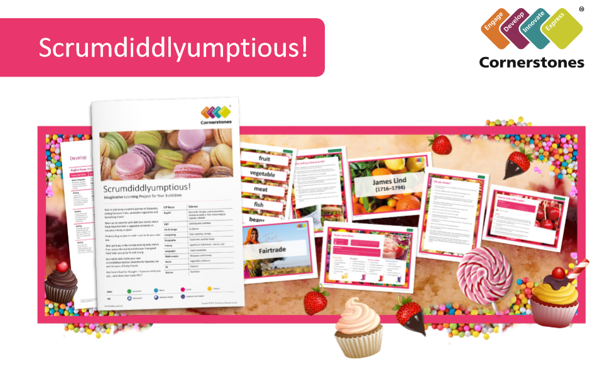
We’re going to enjoy a yummy journey of discovery, sampling fantastic fruits and tantalising treats!
This half term, we’ll visit a local supermarket to find out about the food sold there. We’ll bring back samples of fruits and vegetables so we can investigate them using our senses. Will we like everything we taste? We may try different types of bread and maybe bake our own. In art, we’ll look closely at fruits and vegetables and sketch what we see. We’ll follow recipes and learn about foods from around the world. Our science work will focus on food groups and how food can be altered. We’ll also learn about the fascinating discoveries made by the physicist James Lind.
Finally, we’ll invite you to our Express Event to share what we have learnt.
Express Event will be held on Thursday 28th March from 2.30pm in the Year 3 area/classrooms.
Help your child prepare for their project
This is the perfect opportunity to taste new foods and have a go at following recipes. Why not bake healthy muffins or prepare a slow cooker stew together? You could also sample adventurous foods from around the world. Alternatively you could read the packaging of foods in your fridge to find out where they have come from.

