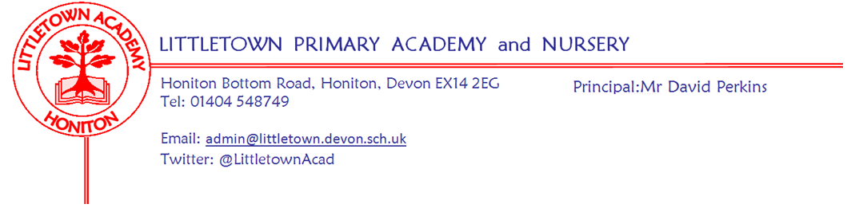
Friday 15th May 2020
Dear Parents and Carers,

I write to you at the end of what has been a very tumultuous week in Education in the UK. As I am sure you are aware, announcements on Sunday evening outlined the phased return to school for Nursery, Reception, Year1 and Year 6 pupils. Since the announcement there has been a significant amount of guidance, discussion, Union communication and debate on the national stage about this and how it will work. As I write, guidance is still changing and debate ongoing. This has made it impossible to get to a position to be able to share anything of any detail with parents at this stage. I apologise for this, but hope you can understand and appreciate this given the circumstances. What I can tell you is that my Senior Leaders, teachers and I, along with the Chair of Governors have been working incredibly hard to discuss and consider scenarios, options and potential plans. I have also been in lots of meetings with Headteachers across the County and working closely with other Heads in the Honiton Learning Community. At a time when it seems school leaders and teachers are being unfairly criticised in some media, Littletown staff have supported the key worker and vulnerable pupil provision at school, facilitated the remote learning for their classes not in school and attended many meetings and discussions about phased opening. I would like to thank them for all of their exceptional hard work this week. Next Wednesday (20th May) is National Thank a Teacher Day. https://thankateacher.co.uk/thank-a-teacher-day/

I can also tell you that these plans we are working on are within overriding principles that make school as safe as possible for children who return to school, protect staff in terms of safety and workload, ensure the continuation of key worker and vulnerable pupil provision and allow the continuation of facilitating remote learning for those year groups not able to attend. Structuring provision to assist parents to return to work will be a consideration, but will not take precedence over the considerations listed above. Thank you to all the parents of Nursery, Reception, Year 1 and Year 6 pupils who completed a google form consultation for me early in the week. This detail has helped us formulate our approach. There will be further consultation when we share proposed plans in the coming weeks. Today, Dawn Stabb, Head of Education and Learning for Devon County Council, has written a very informative letter to parents regarding the planned reopening. It is attached to this newsletter for your information. As ever, do get in touch if you have any questions during this time of great uncertainty.

Thank you to everyone who shared amazing photos of VE day celebrations last Friday. It was amazing to see these steadily flow in via facebook and Twitter. A memorable day for many families. Apologies if you sent an email and the photos have not yet appeared, I have been having technical difficulties in saving the photos to upload.

Finally, following feedback from teachers and some parents we have changed the way we celebrate star pupils. Rather than being listed in the newsletter and on year group padlets, star pupils will receive via the parent a special email from the class teacher and myself congratulating them on the achievement. This will hopefully make this more sensitive to families where circumstances make remote learning more challenging. Thank you to those who gave considered feedback on this.

Yours faithfully,
David Perkins
Principal

