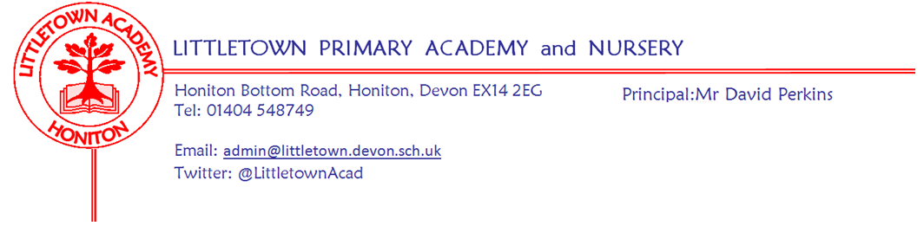
Friday 3rd July 2020
Dear Parents and Carers,

Today marks the end of our Phase 1 of reopening for Nursery, Reception and Year 1 children alongside children of those who are critical workers. I know I have thanked staff a lot for their work over the last few weeks, I reiterate this thanks again today, but in addition, I would like to specifically mention Mr Firth and the site cleaning team. Since June 15th we have had a lot of extra cleaning every day to ensure the school is as safe as possible for children and the team have worked really hard completing extra hours cleaning the school. We wouldn’t have been able to safely open the school without this effort, so I am sure you will join me in thanking them for their efforts.

If your child is due in school on Monday next week, please make sure you have read the letter, checked timings and arrangements and watched the pod video on the website. Please make sure you get in touch to ask any questions prior to Monday via head@littletown.devon.sch.uk

It has been another week where there has been some fantastic remote learning going on across the curriculum via year group padlets. Please pass on a well done from me to your children for all their hard work at home.

Yesterday, the Department for Education released it’s guidance for the full reopening of schools from September. Although there is much detailed planning to be done regarding the detail, it has allowed me to share with you some answers to some big questions we had about next year. I am pleased to say that all children in all classes will be able to return to school in September. Classes will operate as pods of 30. It looks like we will still need to operate staggered start and finish times to avoid overcrowding at entrances and exits and on the road. I am also pleased to say that we will be able to once again offer breakfast club and after school club provision for children. However, there may be some practical alterations to how this has operated before. Deep cleaning is no longer required from September so school will be open all five days of the week again. My job now, alongside senior leaders and the staff team, is to put the detailed plan together for all children and families. If you do have any questions about next year that I now might be able to answer you can ask me via head@littletown.devon.sch.uk

We are also now able to proceed with finalising staffing structure for next year, allocate classes and write to parents. We have been giving a lot of thought about how to best prepare children for returning to school and transitioning to the next year group. Next week, I will be in touch regarding how we propose to share this key transition information with parents and children, as they get ready for September.

The Government also announced this week that schools will not be open over the summer holiday for children of critical workers. This means that our key worker provision that has been in place every single week day, including holidays, since Monday 23rd March, will finish on Thursday 23rd July.

As restrictions ease again tomorrow, I hope you have a great weekend.

Yours faithfully,
David Perkins
Principal

