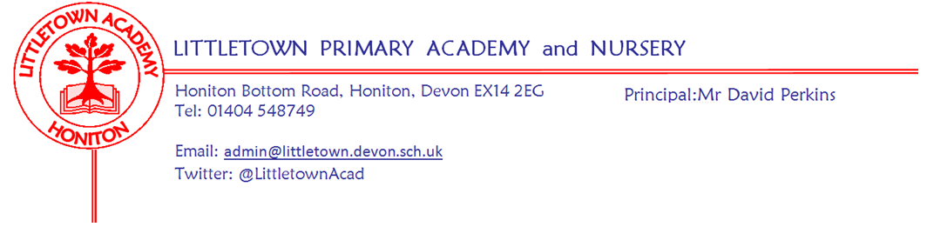

Friday 28th January 2022

Dear Parents and Carers,

I am sure you will all be aware we do continue to have a number of Covid-19 cases in the school. However, this week, these do seem to have remained static rather than increased as we have had broadly as many children and staff returning to school as we have had testing positive. This does mean however, that although restrictions are easing around the country as of yesterday, we are continuing to limit mixing of certain year groups, limit the mixing of staff and ensure adults continue to wear face coverings in communal areas. Year groups where the number of cases reached ‘outbreak threshold’ continue to be advised to conduct daily Lateral Flow tests until further notice. This will be eased once cases fall below the threshold. Daily testing in these cohorts is very clearly making a significant difference in curbing infection. I know it can be challenging administering these tests to young children, but please do these if you can as it helps keep everyone as safe as possible. We know we are not alone in managing lots of cases in school as over 1 million school children (approximately 1 in 8) were off school across the UK with Covid related absences on days this week.

I have greatly missed seeing children and their learning at school who are absent with Covid related absences. If your child has been or is currently isolating and completing remote learning I would love for you to email me head@littletown.devon.sch.uk over the weekend with a piece of remote learning that they are particularly proud of so I can see it and reply to them. I know that lots of children have been doing some amazing learning at home recently so it would be great to see it.

This week, on Monday, some of our Year 2 children represented the school at the KS1 coordination event at Honiton Community College. Yesterday, Year 5 and Year 6 pupils took part in the East Devon Athletics finals at Kings school where they competed and behaved really well. My thanks to Mr Bilcock and Mrs Nuttall for accompanying the children. Please see the children’s report below in this newsletter.

Next week, Year 3 have outdoor classroom on Tuesday, Nursery have outdoor classroom on Wednesday and Reception have outdoor classroom on Friday.

Yours faithfully,
David Perkins
Principal

News from pupil reporters

Nursery
This week, Nursery have been making snowflake posters.

Reception
This week, Reception have been writing speech bubbles and have learned to roll balls in PE.

Year 1
This week, Year 1 have been learning the numbers 11 to 20 and debugging algorithms in Computing.

Year 2
This week, Year 2 have been describing mischievous creatures, learning about what's inside churches, multiplication in Maths and using secret signs.

Year 3
This week, in Year 3 we have moved on to learning about the Bronze age. We have finished our unit on multiplication and division and have been designing a flower garden.

Year 4
This week, in Year 4 we have been making Roman shields, playing wordle and have started a new unit in maths on Area.

Year 5
This week, Year 5 have been investigating how to use hot and cold water to hide gold-dust and learning about fractions.

Year 6
This week, Year 6 have been making Indian posters learning to divide by numbers like 107 and we’ve been creating non-chronological reports about tigers.

Sports report: Year 5/6 East Devon Athletics finals. Kings School Ottery
Year 5/6 students competed in the East Devon athletics final at Kings School in Ottery. They tried their hardest in all the events, supported each other and had fun. The students that competed were: Sam, Logan, Chloe, Lucy, Harley, Rose, Freddie, Thomas P, Jack, Darcey, Sophia and Katie. Logan was nominated by Ufcombe for always trying his best.

Remote learning
With lots of children absent from school, I would like to thank them and you for all the efforts made in remote learning so that they do not fall behind their peers in school. I know for nearly all of you who have had children at home recently, this is at least the second time you have been asked to support your children’s learning remotely like this. When children complete the learning activities and return them to the class teachers, we can keep the progress and curriculum coverage for the classes as on track as possible during this disruptive time. Please do get in touch with us if you are having any challenges with remote learning so we can offer support to you - this includes the loaning of chromebooks where appropriate.

Newsletter corrections
I made two mistakes in last week’s newsletter for which I apologise: In the changed guidance about isolation periods the correct time frame is that a negative test on Day 5 and Day 6 is required for isolation to end on Day 6. I also attached the unamended uniform attachment to match the information in the newsletter. Please find the correct uniform information attached to this newsletter. I would love to say they were deliberate to see who actually reads the newsletter, but more likely it is due to mental fatigue from the Covid spreadsheet!

Covid-19 testing and isolation rules
Those testing positive on a Lateral Flow Device can now end isolation on Day 6 if they can evidence two negative test results. As with all of these Covid-19 rules and guidance, please get in touch with us if you have any questions at all.

Mental Wellbeing
Our second Mental Wellbeing Week 7th - 11th February, will be held during Children’s Mental Health Week organised by the charity, Place2B. The children will be involved in various activities during the week and then a non-uniform day will be held on Friday 11th February to raise money for the charity ‘Place2Be’ and wellbeing at school, 50p per child/£1 per family. The theme for the non-uniform day will be ‘Dress to Express’.

If you have any used, clean small yogurt pots (not the large family size pots) which you were going to put in the recycling bin please could you bag them up and bring them into school by Friday 4th February. I need enough for every child in the school!

Week Beginning 31st January 2022 events
Monday 31st January | Tuesday 2nd February | Wednesday 3rd February | Thursday 4th February | Friday 5th February
 | Year 3 outdoor classroom | Nursery outdoor classroom |  | Reception outdoor classroom

PTFA news
Sadly, we thought it sensible to postpone the Year 3 cake sale this week. Please see here news from the PTFA about events we can hold.

PTFA News
Thank you to everyone who supported our fundraising last term. Despite not being able to hold our usual events we still managed to raise nearly £500 from our Christmas cards, and another £900 from the Christmas raffle, Jolly Jars, refreshments at the performances and the colouring competition. The cake sales and Amazon Fundraising also added to our funds. As a result we were able to provide each class with a gift delivered by Santa at the end of term, which the children asked for, and we will be able to pay towards a trip or activity for each year group this year. This term we will continue to look for ways of being able to raise funds safely.
In light of the infection rate we decided that it was safer to postpone the year 3 and year 2 cake sales for the time being. Instead we are organising a Krispy Kreme doughnut sale on Friday 18th February. There will be the chance to pre-order boxes of doughnuts to avoid queuing on the playground and these will be given out on the day. There will also be some to buy on the day too. Letters will be going out next week with more details of how to do this.
We will also be arranging other fundraising during the term. Please continue to support us as we try to continue offering those extras that benefit all the children in the school.
Community news

Honiton Rugby club flyer
Please see here a flyer for U7s and U8s training for Honiton RFC.

