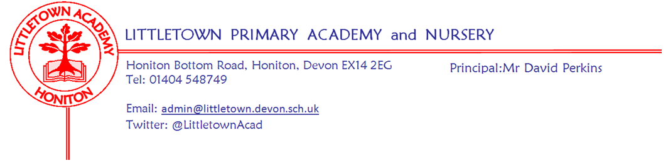

Year 3 Summer Term 2021 Information

Welcome
We are very pleased to be welcoming back the children for the summer term in Year 3. We have lots of exciting activities planned for the children to help them with their learning.
Literacy
For the first part of the summer term, we are continuing to read The Great Kapok Tree by Lynne Cherry. Before Easter, the children wrote a persuasive argument about the effects of deforestation. We will now look at kenning poems, create leaflets about animals which live in the rainforest, followed by a class book about the importance of rainforests. During the second part of the summer term, we will be reading The Pebble in my Pocket: A History of our Earth by Meredith Hooper. Writing outcomes for this text will include free verse poems and an explanation text.
Maths
Maths lessons will take place every day using Power Maths. This term will focus on fractions, time, angles and properties of shape, mass and capacity. The children will continue to develop their multiplication facts fluency using Times Tables Rock Stars.

Cornerstones Topic
Our topic for the first part of the summer term is ‘Predator’. We have sent a letter home with more information including ways to support your child at home with this theme. After ‘Predator’, our last topic will be ‘Tremors’ and the information for this topic will be sent out the week beginning 24th May.

PSHE (including Relationship, Sex and Health Education)

Relationships topic: In this topic we will be focussing on family roles & responsibilities, friendships, keeping safe online, being a global citizen, being aware of how choices affect others, awareness of how other children have different lives and expressing appreciation for family and friends.

Changing Me topic: In this topic we will be focusing on how babies grow, understanding a baby’s needs, outside body changes, inside body changes, family stereotypes and preparing for transition.

Guinea Pigs
We have welcomed back the guinea pigs, Carrot and Toby this term. Year 3 and the Mental Wellbeing Ambassadors will have responsibility for looking after them. Children will not be able to visit the guinea pigs unless we have a completed consent form. If you have not seen the consent letter please let your child’s teacher know and we will send home a new letter.
Key reminders
Outdoor Classroom: 3JS/SD will be having their Outdoor Classroom Day on Wednesday 19th May. In the morning we will visit the river and carry out the activities which were postponed due to the weather and then lockdown! In the afternoon we will carry out activities in the school grounds. Children will need to come to school in old clothes, wellies and a change of clothes in case they get wet in the morning. More information will be provided nearer the time.
3RB/GH will have Outdoor Classroom Day on Tuesday 18th May. This will take place at school as their river trip took place during the autumn term. More details will follow shortly about the activities on this day.

P.E. All children will require a PE kit in school all week, especially on their timetabled PE days of Monday & Tuesday for 3RB/GH and Tuesday & Friday for 3JS/SD. They are also allowed to wear tracksuit bottoms and tops when the weather is colder. Please remember to name all kit and uniform just in case it is mislaid by the children.
Reading Records: Reading Records need to be handed in to school on a Monday and House Points will be given if children have read five times in a week. Children can record their own reading in their Reading Record but please could you check they have completed it before they hand it in.

Home Learning: Cornerstone home-learning activities will be sent home at the beginning of each new topic which are optional to do and children will be able to earn House Points for each piece completed. We will also share their work as a class towards the end of the topic. We will expect children to learn multiplication facts using Times Tables Rock Stars. Please let your teacher know if your child does not have access to a computer to do Times Table Rock Stars or Spellodrome and we will provide them with the opportunity to access it during the school day.
Water Bottles: Please ensure your child has a bottle of water (not juice) in the classroom for drinking throughout the day. They may have juice in their lunchbox but no fizzy drinks.

Packed Lunches: We have peanut allergies in school so we ask that no children have nuts or nut based snacks/spreads in their lunchboxes. We are a healthy school and ask that children do not bring in chocolates or sweets for lunch.
School Dinners: Please ensure you book your child’s school dinner by Friday midnight for the following week. If your child does not eat enough school lunch we will send a note home to inform you.

Medication: Please let us know if your child has to take any prescribed medication at school. There is a green form for you to fill in so that we can administer it. We can only give prescribed medication and the medication must have the prescription label on. Please phone the school if your child is off sick. If you have a medical appointment please let the office know.

Birthdays: If it is your child’s birthday they can come to school in their home clothes. Please do not bring cake/sweets.

Key dates for the Summer term
Parents Evenings: Week beginning Monday 26th April 2021

Bank Holiday: Monday 3rd May 2021

Half Term: Monday 31st May to Friday 4th June 2021

End of Term: Tuesday 27th July 2021

Thank you for your continued support,
Mrs Davis, Mrs Searle, Miss Bodgin and Mrs Huguerre
Mrs Searle & Mrs Davis: class3jssd@littletown.devon.sch.uk
Miss Bodgin & Mrs Huguerre: class3rbgh@littletown.devon.sch.uk

