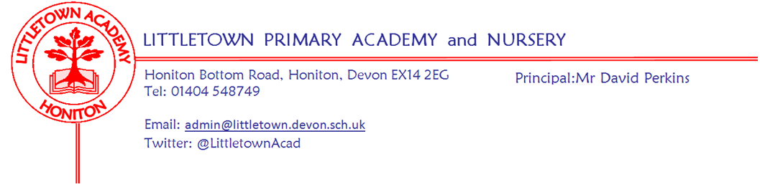
8th November 2019
Dear Parents and Carers,

Welcome back to the second half of the Autumn Term. I hope you all had a very enjoyable two week half term. Over half term on 1st November five of our Year 6 girls cross country runners braved the conditions to take part in the East Devon finals at Bicton College. The girls ran brilliantly and staff were very impressed with their determination and self belief. My thanks to Mrs Veevers for giving up part of her holiday to accompany the children and to parents who assisted with transport for the event.

We once again started the half term with our ACE awards assembly celebrating the attitude, commitment and effort of 84 children from across the school since September. This is always an excellent way to start a new half term.

On Tuesday we welcomed the Donkey Sanctuary to do some work with some of our artists designing Christmas cards. All KS2 children brought home a design sheet for them to complete at home if they wish and return to the collection box at Reception. The overall winning design will be printed and sold at their sanctuaries and online for Christmas 2020.

The children from year 3 visited Adelaide Lodge this week, with the residents they coloured in pictures and completed word searches with a Bonfire and Fireworks theme.

It was wonderful to see so many parents at the Year 3 express event on Wednesday afternoon, I hope you all enjoyed your Scrumdiddlyumptious food!

Yesterday, eleven Year 5 and Year 6 children represented Littletown at the Honiton Learning Community Hi5 Netball competition. They thoroughly enjoyed their first non-competitive Netball experience and showed lots of effort and determination and they are now looking forward to their first competitive experience.

Next week is National Anti Bullying week. We will be taking part in the spotty socks event on Tuesday - please see information below. Next Friday we will be supporting the ‘Big Morning Move’ for Children in Need. Please see the attached letter from the PE team.

Finally, I hope children enjoy their school disco this evening. My thanks to the PTFA for organising this event.

Yours faithfully,
David Perkins
Principal

News from the children
Nursery
We have made firework pictures using paint and crayons.
We made bread stick sparklers.

Reception
We went on an autumn walk.
We wore our pj’s, drank hot chocolate and cooked biscuits.

Year 1
The queen came to school and visited our classroom
We did our house games.

Year 2
We made safety posters.
We found out what noise elastic bands make.

Year 3
We had our express event
We made sandwiches

Year 4
We are making jukeboxes.
We have put our favourite songs in a play list.

Year 5
We are feeling refreshed after half term .
We have been practising for our express event .

Year 6
We have made model anderson shelters.
We have been doing mental calculations in maths

Messages
Odd socks day
On Tuesday 12th November as part of National Anti Bullying Week 2019 we encourage children to wear odd socks to showcase the value of variety, difference and individuality. Further information can be found here: https://www.anti-bullyingalliance.org.uk/anti-bullying-week/odd-socks-day/odd-socks-day-2019

School Photographs
Thursday 14th November is School Photograph day, if you would like to have a photograph of your child/children’s siblings who do not attend Littletown Primary/Nursery please come into school at 8.00am. All siblings who attend Littletown Primary/Nursery will have their photograph taken together within the school day.

School events/Dates
Week beginning 11th November :
Monday | Tuesday | Wednesday | Thursday | Friday
KS2 co-ordination event | Odd socks day | 9.15am - 5CB Express Event in the hall  2.30pm - 5ZU Express Event in the hall  Year 3 & 4 Literacy Information Evening - 6pm | School Photographs | Children in Need sports wear  9.30am Open Day for Reception children September 2020

Community news
Christmas in Honiton Earlier in the week, children came home with a raffle ticket with the chance to win a Christmas Tree and £100 for your school. This is from Honiton and District Chamber of Commerce in partnership with Honiton Town Council. On Saturday 16th November the Christmas celebrations are starting in style:
· A Toy Fair in Mackarness Hall from 3-8pm.
· Honiton Town Band will be playing around St Paul’s Christmas tree from 5pm onwards.
· Gift Bags for children.
· A lucky draw, with 5 Christmas tree winners, and the first winner also winning £100 for their school.
· Mince pies and a visit from a white bearded gentleman in a red suit on a sleigh.
There is a special post box for raffle tickets outside St Pauls Church on the afternoon of the event, and the draw will take place at 5.30pm prompt.

Vacancy
Part time Clerk to Governors
Contract: Permanent
350 Hours per annum
Salary: Scale D between £10.14 – 11.41
Closing date: Friday 15th November 2019 at 12.00 Noon
Reference: Littletown Primary Academy
Location: Honiton, Devon
Establishment: Littletown Primary Academy
Contact name: Mr David Perkins
Address: Honiton Bottom Road, Honiton, Devon, EX14 2EG
Telephone 01404 548749 Email: admin@littletown.devon.sch.uk
Description
The Governing Body of Littletown Primary Academy and Nursery are looking to appoint a highly organised individual with a professional manner and effective communication skills to support its work. Duties will include attendance and minute taking at governors' meetings, the preparation and electronic distribution of agendas, minutes and correspondence for all meetings, maintaining a school policy review cycle and an annual cycle of governor business, maintaining governor areas of the school website, ensuring all statutory information is up to date, supporting the induction of new governors, guiding the Governing Body on procedural matters and being the school's Company Secretary. Training will be provided. Discretion and flexibility, plus excellent organisational and computer skills are essential in this role.
The hours will be 350 hours per annum to be worked flexibly to fit in with the cycle of governing body business during the year. Meetings are normally held monthly(term time) at 5.30pm on a Tuesday. Additional meetings may be required for formal procedures. If you feel that you have the skills and abilities that we are looking for, we would be very pleased to hear from you.
In return, we can offer you:
• A nurturing and exciting place to learn and work – Ofsted 2019
• Happy staff, who work together as a team.
• A commitment to professional development.
• A vibrant school with good resources.
Littletown Primary Academy is committed to safeguarding and promoting the welfare of children and young people and expects all staff and volunteers to share this commitment. The successful candidate will be required to have an Enhanced Disclosure and Barring Service check in line with the Government’s safer recruitment guidelines.
Littletown Primary Academy is committed to equal opportunities.
Closing date for application: Friday 15th November 12 Noon
Interviews: Monday 25th November 2019
If you do not hear from us by 16th November 2019 then please assume your application has been unsuccessful.

