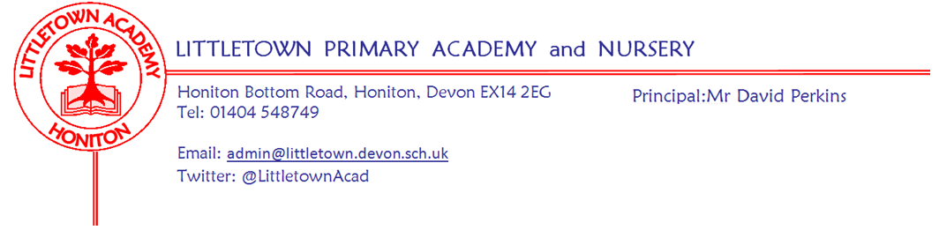
Friday 25th September 2020

Dear Parents and Carers,

Good afternoon, another busy week flies by at Littletown. It has been so lovely to welcome you all each morning and see the children excited and ready for school. Thank you all for your continued support, especially at the beginning and end of the day, the lining up on separate pavements and keeping your children close to you whilst on the school playground helps significantly. In between these dropoff and pickup times the children continue to embrace all of their new learning opportunities and are keen to share their opinion on how school is going….

‘This is the best school ever! We love the reading area, the playground and outside. We like seeing our friends, doing maths, writing and school dinners. We enjoy working in class, being back learning, and seeing friends. The washing hand system is easier and so much better and it is safe in school!’

I am fully aware you may be feeling bombarded with messages but please do take a moment to read all of the updates below. It is fundamental to share both the government advice/changes and ‘in school tweaks’ with you as soon as possible. Hopefully this will reassure you that we are constantly reflecting on our practice and working with you to make school life as successful for both the children and the parents as we can through these uncertain times. After School Club, Parents Evenings and Covid Guidance are examples of these - please see below.

New children sept 2021
Please remember that if you have a child due to start in Reception September 2021 the application process through Devon admissions will be open 15th November 2020 -15th January 2021.
We are unable to offer visits into school at present, however, we are in the process of creating virtual tours and information padlets for new families for both Reception and Nursery families. (Further details to follow in the next few weeks).

Mental Wellbeing Week
During the week of Monday 5th October, we will be holding the first of three Mental Wellbeing Weeks in school. The children and staff will be carrying out lots of wellbeing activities throughout the week culminating in 'Hello Yellow Day' on Friday 9th October which is when we raise money for the charity Young Minds.

On Friday 9th October, for a donation of 50p per child/£1 per family, the children are invited to wear non-uniform; if they do have anything yellow to wear that would be fantastic but not essential.

Parents Evening
As many of you are already aware we usually hold our first Parents Evening consultation just before half term and invite parents/carers into school to meet with the class teacher to discuss how their child has settled into their new class. However, with our present risk assessment and the government guidance advising minimising visitors into school we are unable to have parents and carers into school. We have been considering ways to safely update you on how your child has settled back into school and have decided on phone call consultations during the final week before half term.

These will work in a similar way to the face to face meetings with the class teachers choosing 2 days after school between 3.30pm and 6.30pm to make 10 minute calls to each parent/carer. The list of specific class evenings will be emailed out next week alongside a google form asking you to give us a preferred number to call you on. The teachers will attempt to call each family twice followed by an email if uncontactable by the end of the first week after half term. Please be aware that the caller ID may appear as withheld/no caller ID. We are aware that many parents work, as they do on our usual parents evenings, but hope that knowing which evening you will be called will help. This is not our preferred way to communicate with you all, but I hope you are in agreement that the balance of communicating and safety has been carefully considered.

Breakfast club and After school club Update
The first half term has gone so well with the separated pods and the advanced bookings through google forms. We had to make some very tough decisions at the end of last term but I am pleased to announce that there can be some relaxation of our booking procedures, whilst adhering to our risk assessment to only two year groups in a bubble, with a maximum of 15 children in the bubble.

We have tried our very best to be as fair as we can to all parents and carers, whilst adhering to our changes in booking arrangements. Therefore, we will be sending fortnightly google forms instead of half termly as we empathise with those who don't know their shift patterns, or their circumstances are likely to change. Please note, this fortnightly booking system is subject to change at our discretion, or if the government guidelines change.

There are links below to both the registration form and the booking form for 2nd-13th November.

Registration form - Must be completed for all pupils attending either breakfast or after school club.
https://forms.gle/d6xKu2LLCZRs36y78

Booking form for 2nd - 13th November
https://forms.gle/gu3NMBFiY9EZrHVY6

Home learning for Covid related absences
As mentioned in the newsletter last week please notify the school if your child is at home isolating due to another family member being unwell/awaiting a covid test result but they are well in themselves, as there will be home learning available for your child via a padlet.

Covid Procedural updates
Below is the link to the latest information and guidance for parents/carers released by Devon County Council, including the documents emailed to you all earlier this week.

https://www.devon.gov.uk/coronavirus-advice-in-devon/children-education/covid19-school-absence/

Finally I would like to wish Mr Perkins a warm return from his paternity leave on Monday. He has definitely been missed over the last fortnight, however, all of his fantastic systems and communication has enabled the children, parents and staff to have had a successful start to the new term.

Yours faithfully,

Michala Hawkins

Vice Principal

