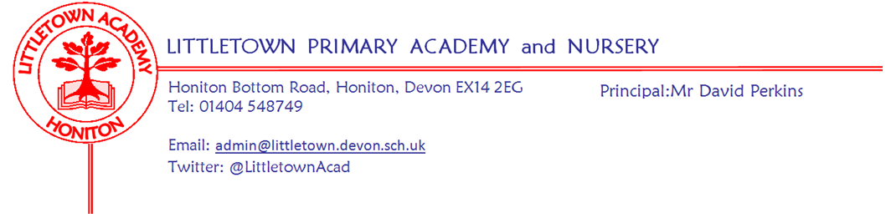
Year 4 – Remote Home Learning Update – 17 April 2020
Dear Year 4 children and parents,
We hope you are keeping fit and well and have enjoyed the lovely weather.
As from Monday 20th April, we are going to use a Padlet Learning Wall to share activities and ideas for your home learning. All of the teachers at Littletown will be using this approach to ensure consistency across the school. Your Y4 Padlet link will accompany this letter.
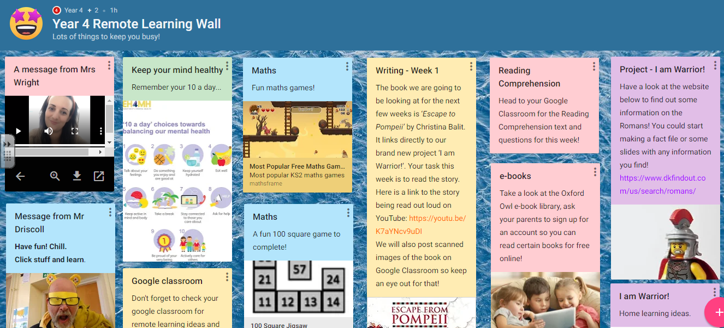
https://padlet.com/year4littletown/tdtzfgc5rl2x

On the Padlet, you will find some messages from your teachers and Mr Perkins. Each box has information, an activity or an idea – if you click on the link, it will take you to the directed website. As time goes on, we will add new frames or update original ones.

Padlets will be predominantly updated ready for the new week on a Monday. But please continue to look at our Padlet throughout the week to see any new ideas and updates. We will continue to use the Google Classroom stream as well, to chat with your friends (and teachers) and share our work in pictures or presentations.

Year 4 children – remember these are difficult times for your parents and carers. Look after them, be as helpful as possible and do not stress over Home Learning activities; if you find it too stressful or a link won’t load, don’t worry. You can always message us and ask for help on the Google Classroom stream.

Remember to stay in contact with your friends through our Google Classroom or other devices and support each other. It’s odd being at home all the time but this will pass and you will be back to school again – so work hard to keep learning new and exciting things, keep exercising and having fun but most of all be the amazing, creative children that you are!

Parents, if you have any questions or would like to send examples of your child’s learning, please use the class email addresses:

4SD: class4sd@littletown.devon.sch.uk
4GW/GA: class4gwga@littletown.devon.sch.uk

Take care and stay safe,

The Year 4 Team

Mr Driscoll Mrs Wright Mrs Arni-Tossell Mrs Barrows Mr Desborough Mrs Mills

A message from Mrs Trim and Mrs Childs:
This is the link that all parents can use to access the SEND/SAFS padlet page. There is a lot of useful information, activities, links... for our SEND children and families.

https://padlet.com/lianechilds/ewjn9i9gxfpw

