Homework at Littletown Primary Academy

As you will be aware we have been undertaking a full review of the homework approach at the school. There has been a thorough consultation with staff, parents and children along with a full review of current pedagogical research on the subject from around the globe.

Whole countries differ in their approach (eg Finland don’t do homework at all whereas China set many hours a day) and although there is general consensus amongst teachers about the impact, parental views also represent a full range of opinions.

Following the review, here is an overview of the findings, the results of the parental survey you participated in and the leadership team’s plan between now and the end of the academic year when it will be fully reviewed.

The Consultation

The Venn diagram below shows the ways we engaged with staff, parents and children, the key overriding points and where they overlap.

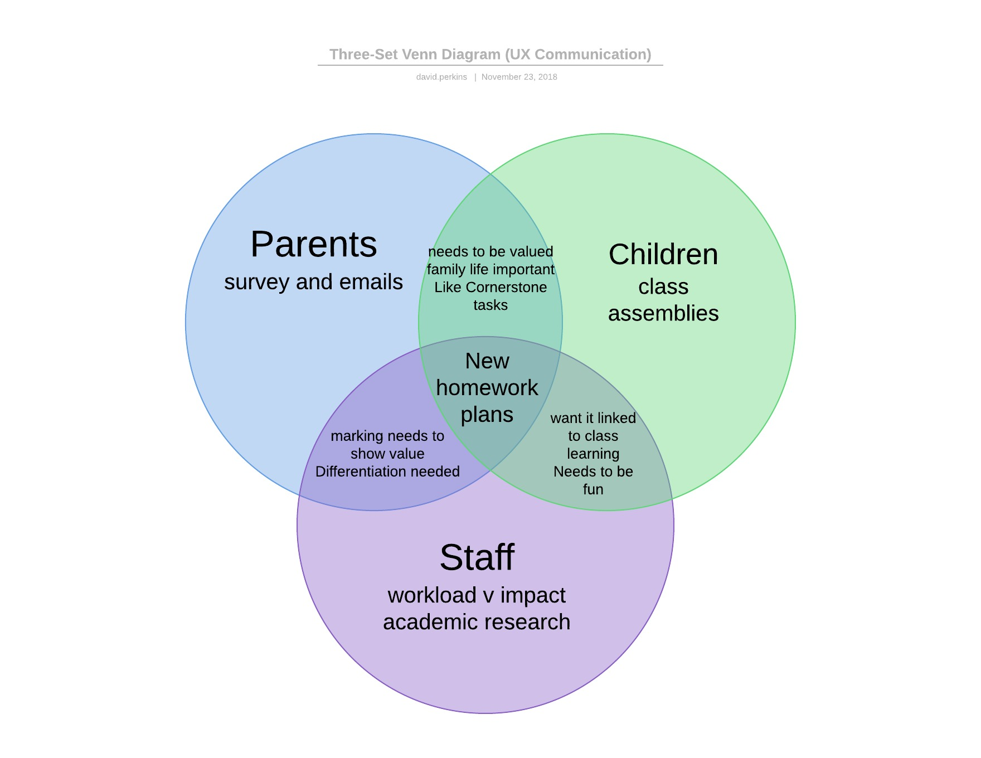

Therefore we should be focussing on the key principles of:
- Home / school links of approach
- Keeping it engaging and fun
- Being impactful and therefore valued by teachers
- Easily differentiated and accessed at learner level
- Based on academic research and evidence
- Considers family life and teacher workload
- Involves the Cornerstone enrichment experiences

The parent responses in full

Although nothing here scored over a ‘3’ it is pleasing to see that the most agreed with statement is that parents value homework, albeit more than children and teachers.

A very equal distribution curve regarding the negative impact on homework so this really seems to depend on family and age of pupils from emails received.

Pretty clear evidence that parents don’t feel homework should be increased.
Spread of views on keeping it the same - Year 6 parents in particular keen not to lose the homework currently in place as valued as preparation for secondary school education and valued in class lessons by the teachers.
Not an overall appetite for homework being abolished
Great to see that overall Cornerstone activities are valued by parents and children at home - many references in emails, especially where these are then used in sharing assembly events.

Research and evidence links

The Education Endowment Fund undertook a massive piece of national research looking at factors in schools which impact on pupil outcomes and give value for money. Here is a link to the homework research which although very low cost, scores a very low impact rating at Primary level.
Parental engagement is considered the key variable along with a clear rationale and connection to class based learning.

The full page summary of this research can be found here: https://educationendowmentfoundation.org.uk/pdf/generate/?u=https://educationendowmentfoundation.org.uk/pdf/toolkit/?id=132&t=Teaching%20and%20Learning%20Toolkit&e=132&s=

The importance of reading (bite size article)
Research studies show that reading is by far the most powerful variable in improving pupil progress and life chances at Primary school. Research shows 20 minutes a day is the optimum amount of time Primary age pupils should spend reading. Forgive the American context of this research, but this is a key image:
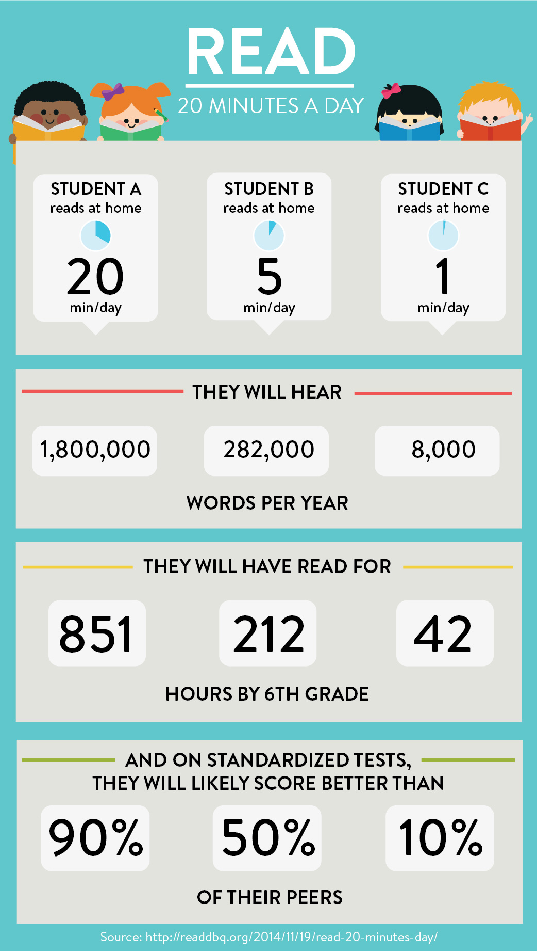
The full article can be found here: https://www.wcpo.com/brand-spotlight/how-reading-20-minutes-a-day-impacts-your-child-amazon-kindle
The importance of Maths fluency (times tables)
International research is pretty unanimous in now accepting that times tables fluency is a key indicator of later mathematical success due to its foundational nature. Indeed the Government are introducing a statutory screening test for times tables for all pupils in Year 4 next year. There are lots of articles out there, but I like this one:
http://theconversation.com/why-all-children-must-learn-their-times-tables-and-fun-ways-to-teach-them-89899
One key element is learning division facts alongside. Those of you who have seen times tables rockstars will know that division is woven into this programme alongside the multiplication facts.

The importance of curriculum enrichment opportunities
Cornerstone offers rich topic based learning opportunities which teachers share at the start of each topic. This helps parental engagement and allows elements of choice in time, task and presentation to the children.
If you read any articles about whether homework is good or not (and there are plenty out there) they will normally say written task based homework is rubbish, but creative child initiated homework is tremendous.
How a certain group of international schools consider this is an interesting read: https://www.acs-schools.com/homework-waste-of-time

What we are going to do at Littletown

Bearing all of the above in mind and after getting agreement from the Governing Board, the Leadership Team and I want to trial some changes to our homework policy for the next two terms in order to evaluate in July as follows:

Children will no longer be set weekly English and Maths written tasks as research shows this is not impactful, teachers find it hard to value it, parents feel it isn’t valued, it is not connected well to class learning and children often find it ‘too hard’ ‘too easy’ ‘boring’.

Children will be expected to try their best to read for 20 minutes a night at home instead of written homework tasks as research shows this has the biggest impact. Teachers will have more time to really focus on the children’s reading - Accelerated reader books can be taken home to ensure connectivity between school and home.

Children will be expected to have a little go Timestables Rockstars every day which will be used to improve children’s timestables at home following a very successful trial which has evidenced high pupil engagement, home/school connectivity, teachers (and indeed parents) can really easily monitor children’s activity and progress. Paper resources are available for those without computers.
*More written information on TTRS next week

Children will be encouraged (not forced) to complete learning opportunities within the Cornerstone Curriculum topic over approx a half term to give freedom and choice and increase pupil/parent engagement and home/school connectivity. Also it develops and celebrates a lifelong love of learning and easy to value in class.

Year 6 will still have written English and Maths tasks to complete weekly as this is important preparation for Secondary school, but all homework will be valued and used in class based teaching. Y6 will be encouraged to read for 20 minutes a day and have full access to Timestables rockstars and Cornerstone Curriculum enrichment opportunities.

Year 5 will from time to time get some English and Maths so they are getting used to what awaits them in Year 6 –However, these will not have weekly deadlines so will not impact on family life.

Year 1 will continue with tricky words however, if children reach a maths level when they can access Timestables rockstars they will be invited to do so.

What about spelling..?!

It was very clear from the parent consultation that spelling requires further attention and is going to require a larger specific focus in the Spring Term. I will be seeking a home/school connected (possibly online) system which allows pupil progress at their own level that can be easily accessed by families and easily monitored by teachers.

What about our policy?
As we are trialling new approaches to be reviewed we will not be rewriting the homework policy. This will happen in July following the review for the new academic year 2019-20

If you have any questions or comments about any of this please do get in touch with me head@littletown.devon.sch.uk

