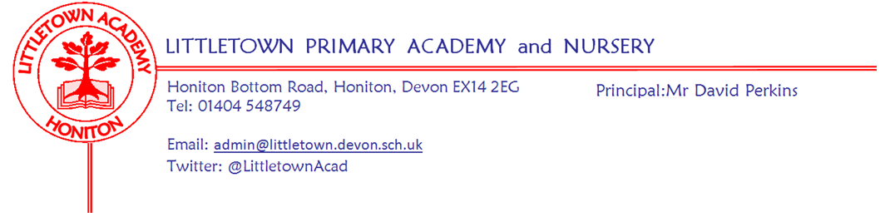
Friday 17th December 2021

Dear Parents and Carers,

A short newsletter today as we all finish to begin our Christmas plans. I need to start by saying a huge well done to all the children in every year group for their amazing Christmas performances over the last two weeks. Mrs Hawkins and I have been really spoiled as we’ve watched 15 performances between us from Nursery last Monday, to the year groups in the hall and Year 5 and 6 evenings in the church. I have to say I have found myself feeling quite emotional watching them at times. I have received lots of very positive feedback from parents about the performances, but the best thing for me has been seeing how much all the children have enjoyed performing and bringing Christmas joy to us all. I would like to thank the staff for all their hard work.

It has been fantastic to see the children enjoying Christmas at school this week as well as doing some great learning too. Yesterday, we had our Christmas dinner all cooked freshly from scratch in the kitchen. Children and staff all really enjoyed their lunch and we would all like to say a huge thank you to Kirsty and her team for all their extra hard work that makes it such a special day at Littletown.

I would like to thank the PTFA for all their hard work over the last few weeks. They managed to sell refreshments and raffle tickets at every single performance. Colouring competition winners were announced in assembly this morning and the raffle was drawn at lunchtime today. The PTFA also facilitated and arranged the visit of my special visitor yesterday who met the children leaving each class a gift during Christmas lunch. As if that isn’t enough, they have also sent you all a quiz and the Elf Trail around Honiton for the holiday. I am very grateful for all their hard work for the school in what continue to be challenging circumstances.

Yesterday you should have received an end of term report from the class teachers. Please do get in touch with teachers in the New Year via class email addresses if you have any questions or queries. I will be encouraging teachers to stay off their emails over the festive period.

Below, you can find a link to some excellent guidance about making electronics safe for children just in case Father Christmas happens to deliver these to your children..!

Finally, I would like to thank everyone who makes up our ‘LittletownBigTeam’; the Governors, the staff, all of you parents, but most of all the children, for making 2021 a very successful year despite it being one of the strangest and most challenging ever. All of us here at Littletown would like to wish you all a very happy Christmas and best wishes for the New Year. I look forward to seeing you all when the children return to school on Wednesday 5th January 2022.

I leave you with the words of ‘It’s Nearly Time..’ the winning poem from our poetry competition held by the house captains recently written by Poppy in Year 6:

It’s Nearly Time…

Looking out my window on Christmas eve
Wondering what I could receive
Enchanting lights line the street
For my eyes, a Christmas treat.

In just a few hours it will be Christmas day
The turkey is waiting on the roasting tray
Mince pies and a cup of tea
Already set under the Christmas tree.

If I close my eyes really tight
I hope to sleep all through the night
And wake up when it’s really time
For the Bethlehem star to shine.

Happy holidays everyone!
It’s time to start the festive fun!

by Poppy.

Yours faithfully,
David Perkins
Principal

News from pupil reporters

Nursery
This week, in Nursery we have been making snowflake biscuits

Reception
This week, Reception have been making party hats and playing party games

Year 1
This week, Year 1 have been making Christmas decorations and cards and Santa came to visit them!

Year 2
This week, Year 2 have been making castles with drawbridges and making origami Santas.

Year 3
This week, in Year 3, we made Christmas biscuits and decorated them. We’ve had a TTRS battle and met with East Devon District council to give ideas about designing a new park.

Year 4
This week, in Year 4, we finished our power maths book and made Christmas cards. We had Christmas dinner.

Year 5
We have been doing a writing assessment and we have finished our first maths book for the first term. We have recently finished Christmas cards for our parents. On Tuesday and Monday we did our Christmas concert in St. Paul's Church.
Year 6
This week, in our classrooms we have been cross stitching Christmas cards for our family. We have also been making mince pies for Mr. Perkins. We are so excited that it is the last day of school.

Staff news

Thank you for gifts and cards
The staff and I would like to thank you all once again for all the cards and gifts. Although this is never expected whatsoever, it is very generous and kind, thank you.

Goodbye to Mrs Huguerre
Sadly, today is Mrs Huguerre’s last day at Littletown after teaching here for 4 years. Mrs Huguerre begins a full time teaching post closer to home in January. I am sure you will join me in thanking her for all her hard work at this schools and wishing her best wishes for the future.

All I want for Xmas.....
I imagine lots of your children may be asking Santa for electronic gifts for xmas, eg phones, tablets and chrome books. Please have a look at the link below to help you feel informed and equipped to keep your child safe.
https://saferinternet.org.uk/blog/4-tips-for-giving-tech-gifts-this-christmas

Week Beginning 3rd January 2022 events
Monday 3rd January | Tuesday 4th January | Wednesday 5th January | Thursday 6th January | Friday 7th January
Bank holiday | INSET day (non pupil day) | First day back for children | 9:15 - 11:15 Axe Valley Wildlife Park visit Y1 in hall

