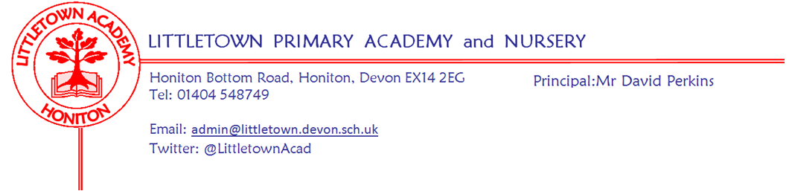
Dear Parents, Carers,

Please find below information on the content your child will be receiving for their Realtionship, Sex and Health Education during the second half of the summer term. The Sex Education is highlighted in red and is within the lessons for year groups 4, 5 and 6. It is important that you are aware of what your child is being taught so you are able to support their learning at home. The Relationship, Sex and Health Education will be delivered weekly by your child’s class teacher using our Jigsaw Currlculm Unit ‘Changing Me.’

Further information on this subject and the Relationship, Health and Sex Education policy can be found on the website (as emailed out to you for the consulation in the Spring Term).

If, after looking at the content you choose to withdraw your child from the Sex Edcuation offered at Littetown you will need to contact myself or Mr Perkins to discuss your decision.
Initially we will refer you to the policy, which explains the how and why we have decided to teach Sex Edcuation, reminding all parents and carers of the key focus of safeguarding your children through educating them about Sex, We wil ask you to share your reasons for your decision, and respect the outcome.

(Please note: If your child’s class is closed due to Covid or your child is off self isolating this curriculum content will not be put onto the Padlet for year groups 1-6; your child will be taught any missed content on their return to school).

As stated in the policy, Puberty is taught as a statutory requirement of Health Education. Sex education refers to Human Reproduction. This Sex Education content listed below in Red is specific content that parents can choose to withdraw their child from.

Year Group | Relationship, Sex and Health Edcuation Learning Outcomes
Reception | - I can name body parts  - I understand we all grow from babies to adults
Year 1 | - I understand life cycles of animals and humans  - I can talk about changes as we grows  - I can identify parts of the body that make boys and girls different and use the correct names for these  - I know to respect our bodies and understand which bits are private  - I recognise that as we grow and learn we change too
Year 2 | - I understand life cycles of animals and humans  - I can talk about changes as we grow from young to old  - I can identify parts of the body that make boys and girls different and use the correct names for these  - I appreciate that some parts of our body are private.  - I understand there are different types of touch and can say what I like and don’t like
Year 3 | - I understand the changes in animals and humans as they grow  - I understand how babies grow and develop in the uterus  - I understand how boys and girls bodies change on the outside  - I understand how boys and girls bodies change on the inside as we grow and begin to understand why these changes are necessary so that we can make babies when we grow up  - I am beginning to recognise stereotypical ideas
Year 4 | - I understand that some of my personal characteristics come from my birth parents  - I can name the internal and external parts of the male and female body that are necessary for making a baby and understand how a baby is made  - I can describe how a girl’s body changes, including menstruation  - I understand there are changes in our lives, some we can control and some we can’t.
Year 5 | - I am aware of my own self image and how my body image fits into that  - I can explain how a girl’s body changes through puberty and understand the importance of looking after yourself physically and emotionally  - I can explain how boys bodies change through puberty  - I understand that sexual intercourse can lead to conception and that is how babies are usually made. I also understand that sometimes people need IVF to help them.  - I can identify what I am looking forward to about becoming a teenager and understand this brings growing responsibilities.
Year 6 | - I am aware of my own self image and how my body image fits into that  - I can explain how girl and boys bodies change through puberty and understand the importance of looking after yourself physically and emotionally  - I can describe how a baby develops from conception through the nine months of pregnancy, and how it is born  - I understand how being physically attracted to someone changes the nature of the relationship and what that might mean about having a girlfriend/boyfriend  - I am aware of the importance of a positive self esteem and what I can do to develop it  - I can identify what I am looking forward to and what worries me about transitioning to secondary school

Yours Sincerely
Mrs Michala Hawkins
Vice Principal

