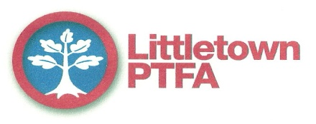

I hope you all had a good Christmas break. We have another busy term starting off with a disco on Friday 18th January. A great way to have some fun after Christmas is over! Entrance is £2 and this includes drink and crisps.
If anyone is able to help on the night please let me know or sign on the board.

School Disco: Friday 18th January 2019

Key Stage 1 (nursery to year 2) 6-7pm
All children for the above disco must be accompanied by an adult for the duration

Key Stage 2 (year 3 to year 6) 7.15pm – 8.15pm
Children must be collected from the school hall and will not be allowed to leave unaccompanied.

£2.00 entrance fee to include crisps and drinks.

If your child has any allergies or medical conditions which we might need to be aware of whilst your child is at the disco please let us know.
There will always be members of staff present but the PTFA are ultimately responsible for the running of the disco. We want everyone to enjoy their evening and work hard to make this happen. Any children who persistently misbehave may be prevented from attending future discos.

If you would like to help serve drinks or do tattoos on the night,
please sign up on the PTFA noticeboard or contact
Sarah Ryerson on 07481 908662 or sarah@ryerson-sound.com.

Thank you.

Other PTFA events this term

Wednesday 16th January – PTFA meeting at the Heathfield Inn 8pm
Friday 25th January – Year 4 cake sale after school
Friday 1st March – Year 3 cake sale after school
Friday 8th March – Quiz evening at school (more details to follow)
Friday 15th March – Disco
Friday 29th March – Year 2 cake sale after school
Friday 29th March – Easter Bingo Night 7pm at school (more details to follow)

