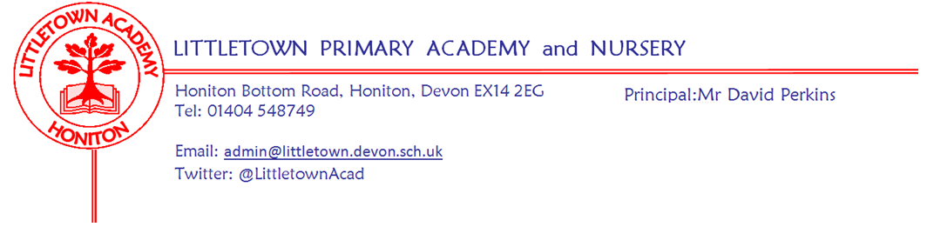
17th April 2020
Dear Parents and Carers,

I hope you have all had a good week and balanced remote learning with family life as well as enjoying the beautiful weather! We heard yesterday from the Government that current ‘lockdown’ arrangements to remain in place for a further three weeks. As I mentioned last week, I am today writing to update you on the future of remote learning for Littletown children for the next three weeks and as long as we remain closed. Obviously we are not able to make physical packs and send home to children as we did for the first two weeks so we have been busy exploring and trialing other approaches. There is a vast range of these and lots of schools doing lots of different things. We have also looked closely at guidance issued by the Department for Education and Teaching Unions. As ever, the decisions we have made are considered to be the best for our school at the time.

Our process for developing these arrangements has been very thorough and we have been following these overarching principles:
- Keep children's mental and physical health and wellbeing as top priority
- Children’s core subject learning can continue in some form as much as possible
- Ensure there is still breadth to the curriculum learning
- Make it fun!
- Be sensitive to family demands, work demands and the fact that parents are not teachers!
- Be sensitive to teacher demands, workload and online protection
- Make learning as accessible as possible for children and parents
- Have whole school consistency, but also progression from Reception to Year 6.

Resources have been explored and trialled by senior leaders and some teachers. Parents from the Parent Forum have given feedback and we have used this in our approach. The teachers have been working hard this week to create the resources so they can be used next week. I would like to thank my Senior Leadership Team, teachers and parent forum members who contributed to this process.

We will be using 'Padlets' as a remote learning wall. Each year group will receive an email from teachers later today with the link to the year group padlet. This will host all of the learning and instructions for children and parents in a simple, clear, engaging and visually engaging way. Each padlet will include short videos from myself and some teachers from the year group to help maintain the connection between children and teachers. There will then be a mixture of documents, web links, written instructions and images to support children's learning. The link to each padlet will be put in google classrooms of children from Y3 to Y6 and links for all year groups will be placed in the remote learning section of our school website here: https://www.littletown.devon.sch.uk/website/remote_learning/463456
Padlets can be opened on smart phones and devices also via the padlet link.

These padlet learning walls will then be updated each week with new content added Monday morning. Some ongoing content will remain with newer content appearing above at the top of the wall. Some learning will be clearly marked with the week it refers to.

Each year group padlet will also contain a link to a padlet of additional resources for parents constructed by our Student and Family Support Team.

Children's learning, in year 3-6, can still be found and submitted via google classroom. Parents can also send images of learning to the new class email addresses set up before Easter. Nursery and Reception children can also add learning to Tapestry. Learning will not be 'marked', but teachers will do their best to value learning and encourage children. Learning in some cases can then be shared on year group padlets in gallery tiles. This will allow children to see what other children are up to!

I am very proud of these learning walls, but there is a lot of content on them which could seem overwhelming. Please remember that the learning there is for you to have a go at over time if you can. We know parents are juggling remote learning with many other things and the top priority must remain the health and welfare of every family.

In line with Union and Department for Education guidance we won't be videoing lessons and uploading them. However, on April 20th the BBC are due to launch their live English and Maths lessons and although we haven't seen these yet, we anticipate these being really good and engaging for children. These could be a great resource for parents and teachers may be able to then base remote learning around these rather than content they haven't been able to teach to the children. I will send you more detail on this in due course.

Don't forget that I am also still looking for #littlebuilders, #littlechefs, #littlegreenfingers and sharing your #littletownwindows. I will also be setting other additional challenges via Twitter and Facebook if you are interested!

Obviously, nothing replicates children being at school, but I hope that these padlet learning resources allow remote learning to be successful for our teachers, parents and most of all, children and that we can keep the Littletown community connection strong despite us all being apart.

As I have said before, this environment is completely new to all of us and we are learning as we go. If you have any questions, suggestions or comments, positive or constructive, about remote learning, either before or after the padlets launch, please don't hesitate to contact me on head@littletown.devon.sch.uk.

Yours faithfully,
David Perkins
Principal

