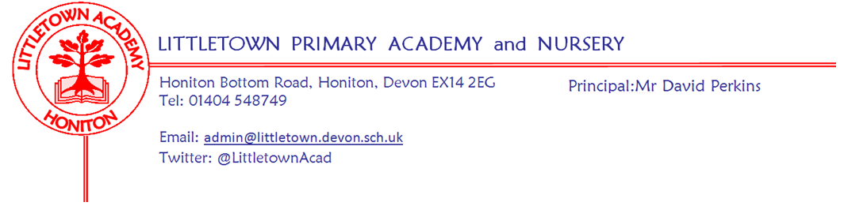
Friday 12th February 2021
Dear Parents and Carers,

Well done for reaching the end of what has been a challenging half term, in so many ways. To all of you who have been homeschooling for 5 weeks and 4 days so far, can I just say a huge thank you. As mentioned several times, the expectations of remote learning are so high compared to the last partial closure and not necessarily where we would set them as a school. I am constantly blown away by the quantity and quality of the learning the children are doing at home in all year groups. I am very grateful to you for the importance and value that you clearly place on remote learning. A huge well done to the children for all their hard work. A well done too, to the children who have been coming to school without many of their friends in very strange circumstances for all their hard work and their brilliant attitude to learning. Hopefully it won’t be for much longer.

As you probably already know, we expect to hear from the Prime Minister on Monday 22nd February about plans for the full reopening of schools. We very much hope that this will see us fully reopening for all children on 8th March, but we will have to wait and see what is announced. It is likely that I will be writing to you in response to the announcement early in that week so please keep an eye out for emails.

Hopefully the children have enjoyed and learnt alot from the safer internet materials we have shared on the padlets this week. Please keep the links we shared for parents somewhere where you can access them if you need them in the future. Although there is no learning next week, most children will be on devices at some point I’d imagine, so please ensure you continue to be vigilant with what your children are accessing. ‘No screen Friday’ seems to have gone well today with lots of great projects and cooking going on around Honiton it seems!

Thank you to all the children who have sent me Little Miss and Mr Men characters over the course of this week. There have been some brilliant characters created and I have really enjoyed looking at them all.

Next week is half term and although I know many of you won’t have time off work and have had to put in complex arrangements for your children, I hope you manage to have a break of sorts. At least there won’t be any remote learning to manage! Please make sure your children have a well deserved rest and recuperate from a hard few weeks.

Lastly, please remember that even though it is half term, I need to know up until the end of Sunday if a child who has been in school develops symptoms for Covid-19 and then remain updated as they go for a test and receive a test result. Please contact me via head@littletown.devon.sch.uk

Yours faithfully,
David Perkins
Principal

