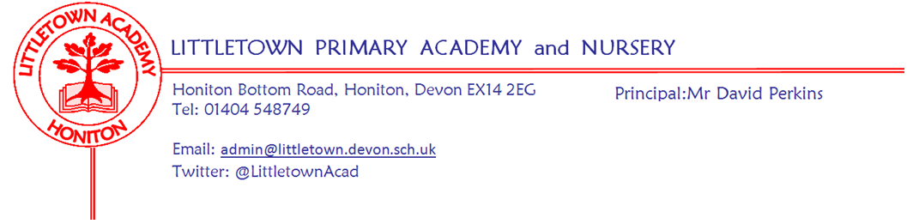

Friday 12th June 2020

Dear Parents and Carers,

As you will know, we welcome back children in Nursery, Reception and Year 1 next week. All parents of returning children, (even if they are already attending school) should have received a letter on Monday, giving lots of details about returning to school. Can I please urge those parents to reread that letter this weekend to ensure they know the protocols to follow. This week, I have been busy making short pod videos for our website. Unfortunately, today I have spent most of the day in the Learning Pit grappling with Youtube! Despite delaying the newsletter until this late, these videos aren’t quite uploaded on to the website. They certainly should be by later this evening, so please visit the website, select ‘pod videos’ on the home page and find the video for your child’s pod by the animal and colour. These videos are half aimed at parents and half aimed at the child so please do share it and discuss it with your child over the weekend so that they know what to expect. Please email me if you have any questions at head@littletown.devon.sch.uk We have been able to learn a couple of things from schools around the country that have been open this week. Please ensure children can do shoe laces/fastenings, zips, buttons, hair bows etc themselves as staff are unable to assist in this without possibly requiring essential personal protection equipment. Please make sure parents and children do not congregate on the pavement outside school before or after school. If you are early, please wait in your car or a distance away from school if you walk.

As you are probably aware, on Tuesday, the Government announced that there is no longer the expectation that all schools will receive all year groups back to school before the end of the academic year. As a large primary school, receiving a significant number of children identified as priority year groups, whilst sustaining key worker and vulnerable pupil provision, we don’t envisage being able to accommodate non priority year groups before the end of the year. This has enabled us to reflect on how to structure remote learning for these cohorts, in order for them to transition successfully to the next year group. Year 5 parents will already have received a letter about shifts in remote learning towards preparing the children for Year 6. We are looking at how to create resources and initiatives which allow transition from year groups and expect to be writing to you more about this in the next week or two.
Please find below in this newsletter, a message from Mrs Childs and the Student and Family Support team regarding how parents can continue to help the overhauling of the My Plan document.

Today Mrs Davis, Year 3 teacher, was successfully appointed as our Mental Health and Wellbieng champion! Mrs Davis will be a full member of the Senior Leadership Team, with the sole remit to assist us in supporting the mental health and wellbeing of the whole Littletown community. She will undertake this role for at least the next academic year, while we continue to navigate through this challenging time. Mrs Davis will carry out this role alongside her teaching. She has some exciting ideas and you will be hearing from her over the next couple of weeks. I am very proud that we are the only school I know of in the country to have a Leadership role purely focussed on helping us to ensure that mental health and wellbeing remain at the heart of what we do as a school.

Finally, after so many weeks with so many children away from school, it really does give me great pleasure to say, even if to just a few of you, see you next week!!

Yours faithfully,
David Perkins
Principal

Important message from the SAFS Team

A huge thank you to the parents that took part in the My Plan survey back in May. Your feedback has enabled me to redesign the My Plan format to improve future parental involvement in your child’s Plan. Please click on the link below to visit the SAFS Padlet page to view the results of the May questionnaire and to review the new My Plan format.

Padlet page link: https://padlet.com/lianechilds/ewjn9i9gxfpw

If you could spare 2 minutes to give feedback on the new My Plan format, please click on the link to a short survey which will need to be completed by the 26th June.

Survey link: https://forms.gle/z3xDiy18KzeNv5Vy7

