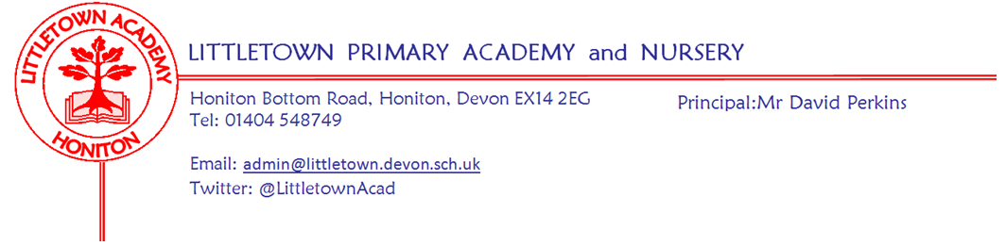

Live . Love . Learn - Littletown
Year 4 Autumn Term 2026 Information
Literacy
In Literacy, we will be studying different types of texts and focusing on different aspects of SPAG (spelling and grammar). Discreet weekly SPAG lessons will support the children with their writing. We will be focusing on two books, ‘Gorilla’ by Anthony Browne and ‘Leon and the Place Between’ by Angela McCallister. The children will be learning how to write a fantasy story and a diary/recount.

The children will also be developing their reading comprehension skills through Accelerated Reader and targeted whole class sessions.
Weekly spellings will be sent home in the children’s spelling journals. These will be tested on Mondays. We will not be using the testing area in the back of the spelling journals so please feel free to use this space for practising. Please continue to listen to/read to your child. They will be able to bring home books from the school library at their reading level. Children are also encouraged to read other books/texts to develop their love of reading. You will no longer be required to record your child’s reading, however the expectation is that they will still read (or be read to) 5 times a week.
Maths
In Maths, each lesson will begin with a Power Up that is designed to give the children a quick reminder of past learning. We then move on to the main focus of that day’s lesson. This term our units will be Place Value - 4 digit numbers, Addition and Subtraction, Measure - Perimeter and Multiplication and Division.
Please encourage your child to use Times Tables Rockstars as much as possible to practise their multiplication and division facts. Towards the end of Year 4, your child will need to take a short online test to check that their times table knowledge is at the expected level. This is a Department of Education initiative to help schools identify pupils who have not mastered their times tables to enable additional support to be given.

PSHE (including Relationship, Sex and Health Education)

Being Me in My World: In this unit, we will be focusing on helping the children to value themselves and know how to make someone else feel welcome and valued. Pupils will discuss how it feels to be happy, sad or scared and identify if other people are feeling these emotions. We will also discuss how behaviour brings rewards/consequences.

Celebrating Difference: The purpose of this unit is to help children appreciate family/the people who care for them. We will discuss strategies to help the children calm down including the ‘Solve it together’ technique. We will also look at bullying scenarios and how we could approach them including ways to help make someone who is bullied feel better.
Topic Subjects
This term, our main project will be history based - ‘Invasion’. This project teaches children about life in Britain after the Roman withdrawal. Children will learn about Anglo-Saxon and Viking invasions up to the Norman conquest. Subjects such as Science, Art, D&T, French, Music, Computing and Geography will be covered in ‘mini projects’ throughout the term. Our Science mini project this term is Food and the Digestive System.
PE
This terms PE topics are as follows;
Indoor PE: Yoga
Outdoor PE: Tag Rugby and Basketball
Key reminders
Book Bags: Please send your child’s book bag (or a back pack) into school every day (with your child’s spelling record).

Clothing: Please ensure all items are named, including PE kit and shoes.

Water Bottles: Please ensure your child has a bottle of water (not juice) in the classroom for drinking throughout the day.

Packed Lunches: We have peanut allergies in school, so we ask that no children have nuts or nut based snacks/spreads in their lunchboxes. We are a healthy school and ask that children do not bring in chocolates or sweets for lunch.

Playtime snacks: Please ensure that snacks are fruit/vegetables for play time.
School Dinners: Please ensure you book your child’s school dinner by Friday midnight for the following week. If your child does not eat enough school lunch we will send a note home to inform you.

Medication: Please let us know if your child has to take any prescribed medication at school. There is a green form for you to fill in so that we can administer it. We can only give prescribed medication and the medication must have the prescription label on. Please log any absences on Arbor if your child is off sick, specifying the reason for the absence. If you have a medical appointment please let the office know and log on Arbor.

Birthdays: If it is your child’s birthday they can come to school in their home clothes. Please do not bring cake/sweets in for other children.

Toys: We ask that toys/valuables are not brought into school.

P.E kits: Please can your child come to school in their P.E kit on P.E days.
P.E days - Tuesday and Wednesday
Key dates for the Autumn term
Friday 23rd October | Outdoor Classroom
Monday 2th October - Friday 6th November | Half term (2 weeks)
Trip to Escot* | Wednesday 11th November
Friday 18th December | Term ends for children
*details to follow
Thank you for your support
The Year 4 Team
Mrs Heywood, Mrs Prangley and Mrs Davis

