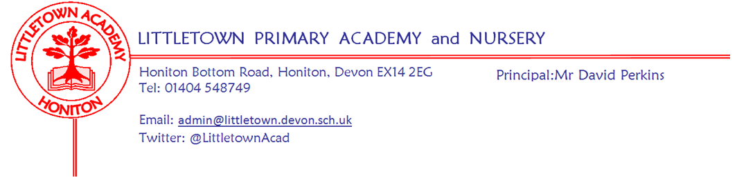
Friday 22nd May 2020
Dear Parents and Carers,

I will keep this week’s newsletter nice and short as I assume you will all feel you had enough school literature to read yesterday!! The letter yesterday remains accessible on our school website. So far, 121 parents have completed the form and this is already helping to inform our planning. A reminder that the deadline for the form is Monday 9am. As mentioned in the letter, I will be checking and replying to emails all weekend on head@littletown.devon.sch.uk Thank you to parents who have given feedback, raised questions and given supportive messages to myself and the school since the letter was shared. Year 6 parents, don’t forget there is a special message from me in the children’s google classroom stream.

Thank you to those who sent messages to the school on National Thank a Teacher day on Wednesday. I know it really means a lot to the teaching staff, possibly more now than ever before.

Children (and perhaps homeschooling parents!) may be pleased to know that next week is Half Term week. There won’t be any learning set on the padelts. Have a rest and enjoy the hopefully pleasant weather. Remember, even though it is half term, I’m still looking to see all our little builders, little green fingers and little chefs as well as anything else you get up to via our facebook and twitter pages.

Finally, Honiton library are running a Sunflower growing competition! Parents can email Honiton.library@librariesunlimited.org.uk with name, address and library card number if they have access to it. Sunflowers will then be sent and In September a winner will be announced after entries have been submitted. winner receives a prize..

I wish you all a lovely Half Term week.

Yours faithfully,
David Perkins
Principal

