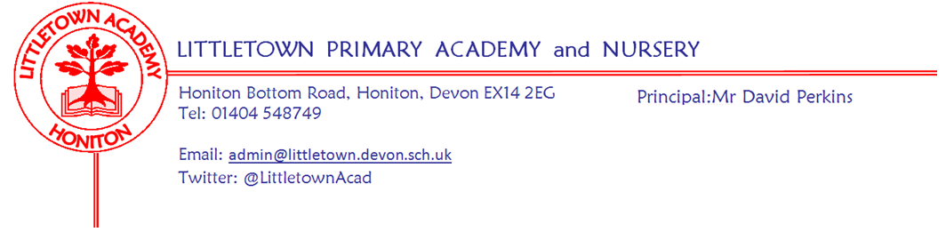
Friday 5th November 2021

Dear Parents and Carers,

A warm welcome back to school after a two week half term which I hope you found enjoyable and restful. After high levels of pupil and staff absence just before half term it has been great to see everyone back this week.

As well as various Halloween and Firework related learning this week, Year 1 launched their new topic ‘Splendid Skies’ with outdoor classroom on Tuesday. On Wednesday children from across Key Stage 2 went to the latest Stockland cross country race. Well done to all of them for running so well and braving the mud and thanks again to the adults who accompanied them.

The children’s flu vaccinations due this week via Virgin Health Care were sadly postponed. Please see a message below from Honiton Surgery for your information and please don’t contact them regarding Flu vaccinations. Please also find below information about our school photos coming up later this month.

Anti Bullying week and Children in Need take place over the next couple of weeks so please see information on these below. Then before we know it we will be approaching Christmas!! We have been discussing this in great detail as a staff and we will share details of our arrangements for performances etc with you early next week.

As you know, I am consulting widely on refreshing the school’s vision and values. Sadly, we were unable to hold the scheduled parents meeting before half term. Therefore, please see a consultation form via google form for all parents to share their views. I am aware that google have changed some settings recently and this has caused an issue for some. I am trying to work this out. If you have an issue with this form, please ring the school to speak with me about vision and values and I can record the responses for you. Closing date for the form will be Friday 19th November. https://forms.gle/qaB2tfuTMRa3e2H27

I hope you enjoy November 5th celebrations this weekend and please make sure you do so safely. Children in Key Stage2 have been reminded about firework safety today.

Finally, my thanks to the PTFA and parents who donated Bags for School yesterday. Thank you also to Year 5 parents for the cake sale after school on the playground today. See you in the queue!

Yours faithfully,
David Perkins
Principal

News from pupil reporters

Nursery
This week Nursery have been making edible sparklers

Reception
This week Reception have been making bats and making silly spells in literacy and running like a ghost and crawling like a spider.

Year 1
This week year 1 have a new topic called ‘Weather’ and they are looking for signs of Autumn.

Year 2
This week year 2 have been learning about Owls in literacy.

Year 3
We have been dissecting Owl pellets and learnt about Diwali in R.E. We have written expanded noun phrases in literacy and have started a new book called The Winter Child.

Year 4
We have been making our own version of the book Gorilla and have been learning about the digestive system.

Year 5
This week in Year 5 we have been looking at different sorts of fairy tales and have started a new book called The Lost Happy Endings. We have also been doing line graphs in maths. We have been learning about all of Henry VIII palaces and houses that he used to party in.

Year 6
This week in Year 6 we have been doing list writing. In maths we have been learning about prime numbers, common factors and multiples. We have been reading a new book, learning more about WW2 and writing posters.

Pupil consent form
This week you should have received a google form link asking for various image consents. Please do make sure you complete this so we can proceed with photographing children within parental wishes. I have been trying to fix a sign in issue with the google form which I am working on. If you can’t get this to work, please call or email the school office and we can fill in the responses for you.

Contacting teachers
Just a reminder as we return after a two week break that we are limiting parent access on site and requesting that parents use class email addresses to contact teachers as much as possible. This allows teachers to focus on preparing learning and receiving the children properly first thing in the morning. Do get in touch if you have any questions.

School photos
I am pleased to say that Tempest photography will be in school on Thursday 18th November. They will be able to do sibling photographs for siblings in school, however, due to Covid-19 restrictions, they are not able to take family photos or photos with siblings who are not Littletown pupils.

Anti bullying week 15th - 19th November
Next week we will be joining in with this years' National Anti-bullying week, including participating in assemblies, anti-bullying activities and odd socks day.

What is Odd Socks day?
Most importantly, Odd Socks Day is designed to be fun! It’s an opportunity to encourage people to express themselves and celebrate their individuality and what makes us all unique!
All you have to do to take part is wear odd socks to school, it couldn’t be simpler! Odd Socks day will take place on the first day of Anti- Bullying Week 15th-19th November to help raise awareness of bullying. We would like to invite families to make a 50p donation to the Anti-bullying Alliance to support them in continuing to coordinate this week every year.
However, you do not have to donate money to take part - the most important thing is the message of Odd Socks Day!
The fundamental theme this year is 'One Kind Word'. I am certain that you will agree kindness is more important today than it has ever been. The isolation of the last year has underlined how little acts of consideration can break down barriers and brighten the lives of the people around us.
Please do have a look at the Anti-Bullying Alliance website for further information
Children in need
The week after Anti bullying week is Children in Need on Friday 19th November and we are inviting staff and children to come to school dressed in their favourite pyjamas to raise money for this year's appeal. Donations of 50p per child or £1 per family to be brought into school on the morning of the 19th. More information regarding the day will be in next week's newsletter.

Community news

Message from Honiton surgery
Honiton Surgery understands that Virgin Health Care have delayed their campaign to deliver flu vaccinations to your children.

Whilst we sympathise with you and understand this has been upsetting, Honiton Surgery are unable to vaccinate your children. NHS England have made it clear they have commissioned Virgin to deliver the campaign and therefore have a duty of care to you.

We are receiving high numbers of calls from parents who are quite rightly upset and some are being particularly aggressive, please understand this is not of my staffs making and we cannot offer your child a flu vaccine.

If you have concerns please approach Virgin Health Care direct on Virgincare.co.uk

British library competition
Honiton library have shared the following information with us regarding a competition which is currently ongoing:
What makes your hero super?
bl.uk/superheroes
From 11 October to 30 November, we’re asking children to create a comic and help us assemble a new galaxy of superheroes! We’re celebrating heroes of every kind – whether they have the power to scale walls, save forests or make someone smile.

Teachers and parents can help themselves to a raft of free online resources. There are top tips, videos and templates to inspire you to make comics, flying heroes and flip-books: https://www.bl.uk/childrens-books/activities/what-makes-a-hero-super

Share your creations
Share photos of children’s work on Twitter @BL_Learning or by emailing childrens.books@bl.uk. On 30 November we’ll pick 5 lucky schools and 5 lucky families out of our (virtual) hat to win National Book Tokens.

